SPRINGBOOT

One of the most important frameworks.
- It provides a large number of helper classes which makes things easier.
- It was initially developed as an alternative to J2EE(Java 2 Enterprise Edition). Bcoz in J2EE, the features of EJB (server-side element that summarizes business logic of an application) were very complex. It required multiple deployment descriptors, multiple interfaces and poor performance of entity beans.
- Spring is now more popular, has great market share and is easy to use.
Goals:
- Lightweight development with java POJOs.
- Dependency injection to promise loose coupling.
- Declarative programming with aspect-oriented-programming(AOP).
- Minimize boilerplate Java code.

Spring Core Framework:
> Core Container: This manages how beans are created. It can read and config files for setting properties and dependencies.SpEL is Spring Expression Language which is used in config files to refer to other beans.
Beans Core SpEL Context
> AOP: It allows you to create the application-wide services like logging, security, transaction, instrumentation etc. and you can apply these services to your objects in a declarative fashion. So just by modifying the config file, that service will be applied to your application.
> Data Access Layer: Communicating with the database.
JDBC ORM Transactions JMS OXM
> Web Layer: This is the home for Spring MVC Framework. All web-applications can be built using Spring Core and make use of Spring Controllers and spring view.
Servlet WebSocket Web Portlet
> Infrastructure: here you can actually make use of class loader implementations to work with different app servers.
AOP Aspects Instrumentation messaging
> Test Layer: This includes mock objects for mocking out servlets and all and all this can be done outside of the container.
Unit Integration Mock

Spring Projects: Additional Spring modules built-on top of the core Spring Framework. Its concept is “Only use what you need”.

Configuring Spring Container:
> Using XML config file > Java annotations > Java Source Code

Configuring using XML COnfiguration:
Inversion Of Control:(XML configuration)
It is a design process of externalizing the construction and management of your objects i.e it says that your application is gonna outsource the creation and management of the objects and that outsourcing will be handled by an object factory.
Spring Container: Its Primary functions include:
> Create and Manage objects > Inject object’s dependencies

Steps to follow Inversion of Control:
- Configure your Spring beans in xml file (bean is simply a java object created by spring container)
In ApplicationContext.xml file, create bean using
<bean id = "giveNameOfId"
class = "PackageOfTheImplementedClass">
</bean>
- Create a spring container (also known as Application Context)
//load the spring config file
ClassPathXmlApplicationContext context = new ClassPathXmlApplicationContext("applicationContext.xml");
- Retrieve beans from the spring container.
//retrieve bean from spring container. When we pass the interface to the method, spring will cast the object for you.
Coach theCoach = context.getBean("IdNameGivenInApplicationContext.xmlFile", Coach.class); //call methods on the bean
System.out.println(methodName());
//close the config file
context.close();
Dependency Injection:(XML configuration)
Allows a program designed to follow the dependency inversion principle i.e the client delegates(assigns authority to another entity) to calls to another object the responsibility of providing its dependencies.Dependency is a library that provides specific functionality that we can use in our application.You simply outsource the construction and injection of your object to an external entity.Injection Types:
> Construction Injection > Setter Injection //> auto-wiring
Steps of developing Constructor Injection:
- Define the dependency interface and class
- Create a constructor in your class for injections
- Configure the dependency injection in Spring config file
Steps of developing Setter Injection:
- Create setter methods in your class for injections.
- Configure the dependency injection in spring config file.
Steps for Injecting Literal Values:
- Create setters methods in your class for injections.
- Configure the injection in the Spring config file.
Steps to Read from a Properties file:
- Create Properties File.
- Load properties file in Spring config file.
- Reference values from Properties File.

Bean Scopes:
Scope refers to the lifecycle of a bean.
- How long does the bean live?
- How many instances are created?
- How is the bean shared
Singleton: Spring container creates only one instance of the bean by default. It is cached in memory. All the requests for the bean will return a shared reference to the same bean. We can have many object references pointing to the same area of memory. Here, singleton is the scope by default. This scope will create only one instance for the interface. There are other Spring Bean scopes like
> Prototype > request > session > global-session
Prototype: Using this scope, a new option is created for each request. Whenever a request is made for this interface, they will create a new instance each time. This scope is good for keeping track of state full data.
Bean LifeCycle:
- Container started
- Bean Instantiated
- Dependencies Injected
- Internal Spring Processing
- Your Custom init method
- Bean is ready for use OR Container is Shutdown > Your Custom destroy method> Stop
You can add custom code during bean initialization OR during bean destruction
- Calling custom business logic methods
- (Setting up) OR (Clean up) handles to resources(db, sockets, file etc)
Spring allows you to add custom code called hooks, where you can actually hook in code to execute during bean initialization or bean destruction.
Steps: 1) Define your methods for init and destroy.
2) Configure the method names in the spring config file. The method can have any access modifier. The method can have any return type. The method can have any name. The method cannot accept any arguments.

Configuring using Java Annotations:
- Special labels/markers added to Java class.
- Provide meta-data(it means data about data) about the class
- Processed at compile time or run- time for special processing.
Why?
- Xml configuration can be too big and long.
- It configures your Spring beans with Annotations.
- Annotations minimize the XML configuration.
Scanning for component Classes
- Spring will scan your java classes for special annotations.
- Automatically register the beans in the spring container.
Steps to create java Annotations:
- Enable component scanning in spring config file
- Add the @component Annotation to your Java classes
- Retrieve bean from Spring container

Spring also supports Default Bean IDs. This is done by making the 1st letter lowercase
Example: Class = TennisCoach --> Default Bean ID = tennisCoach

Spring AutoWiring:
For dependency injection, spring can use auto wiring. Spring will look for a class that matches the property. It matches by type: class or interface. Spring will inject it automatically hence it is autowired.
Three types of Autowiring Injection:
> Constructor Injection > Setter Injection > Field Injections
Steps to create Constructor Injection: (It has less boilerplate code so readability is good )
- Define the dependency interface and class
- Create a constructor in your class for injections
- Configure the dependency injection with @Autowired Annotation.
Steps to create Setter Injection: (It has more boilerplate code so more repeatability )
- Create setter methods in your class for injections.
- Configure the dependency injection with @Autowired Annotation.
Steps to create Field Injection: (We can inject dependencies by setting field values on your class directly. It is accomplished by using Java Reflection)
- Configure the dependency injection with Autowired Annotation
- Annotation is placed directly to the field.
- There is no need for setter methods.
If there are multiple implementations, then use [@Qualifier(desired bean id)] annotation. BUT if both the first and second letter are upper case then the name is not converted.
BeanScopes with Annotations:
- Just mention @Scope(“ScopeType”) above the bean.
Steps to create Bean LifeCycle with Annotations:
- Define your methods for init and destroy
- Add annotations: @PostConstruct and @PreDestroy
- NOTE: for prototype scoped beans, Spring does not call the @PreDestroy method. In contrast to the other scopes, Spring does not manage the complete lifecycle of a prototype bean: the container Instantiates, configures, and otherwise assembles a prototype object, and hands it to the client with no further record of that prototype instance.

Configuring using Java Code (No XML):
Here we will configure the Spring Container using Java code.
Steps to configure using Java code:
- Create a Java class and annotate as @Configuration.
- Add component scanning support: @ComponentScan. (Optional)
- Read Spring Java configuration class.
- Retrieve beans from the Spring container.
Define Beans using Java code:
- Define a method to expose the bean.
- Inject bean dependencies.
- Read spring java configuration class.
- Retrieve beans from the Spring container.
Steps to Inject values from Properties file:
- Create Properties file.
- Load properties file in Spring config
- Reference values from Properties file.

Spring MVC: (https://youtube.com/playlist?list=PL0zysOflRCelAb51IrexpUSeB0dpr9p6g)
It is a framework for building web applications in Java. It is based on the Model View COntroller design pattern. It Leverages the features of the Core Spring Framework (IoC, DI). You have an incoming request coming from the browser, It will encounter Spring MVC Controller. This will actually delegate the request off to a controller code. This controller code is the code that you create that contains your business logic.You create a model and you send the model back to the front controller and the front controller will pass that model over to your view template. So your view template is basically like a HTML page or a JSP page that will take that data and then render a response to the browser.
Benefits:
- The Spring way of building web app UIs in Java
- Leverage a set of reusable UI components
- Help manage application state for web requests
- Process from data: validation, conversion etc.
- Flexible config for the view layer
Components of a Spring MVC Application:
> A set of web pages to layout UI components
> A collection of Spring beans (controllers, services, etc.)
> Spring configuration (XML, Annotations or Java)

Spring MVC Front Controller:
- Also known as Dispatcher Servlet
  - Part of the Spring Framework
  - Already developed by Spring Dev Team
- It will delegate the request to some other objects or items here in our system.
- You (we as a developer) have to create:
  - Model objects
  - View templates
  - Controller classes
Controller:
- Code created by developer
- Contains your business logic
  - Handle the request
  - Store/ retrieve data (db, web service..)
  - Place data in model
- Send to appropriate view template
Model:
- It contains your data
- Store/ retrieve data via backend systems
  - Database, web service, etc.
  - Use a spring bean if you like
- Place your data in the model
  - Data can be any java object / collection.
View Template: The model data comes over to your view template and then your JSP page can read that model data and display it.
- Spring MVC is flexible
  - Supports many view templates
- Most common is JSP + JSTL
- Developer creates a page
  - Displays data
- Other view templates supported: Thymeleaf, Groovy, Velocity, FreeMarker, etc..

Steps to create a Spring Home Controller and View:
- Create Controller class:
- Annotate class with @Controller. This is inherited from @Component. And it supports Scanning.
- Define Controller method
- Add Request Mapping to Controller method
- Return View Name
- Spring is going to use information from its configuration file and it will actually find the view page. So based on the configs, it will look in a given prefix directory and then it will use the view name and then it will append the suffix .jsp .
- Develop View Page

Steps to Read HTML Form Data:
- Create Controller class
- Show HTML form
  - Create controller method to show HTML form
  - Create View Page for HTML form
- Process HTML form
  - Create controller method to process HTML form
  - Develop View Page for Confirmation

Spring Model:
The model is a container for your application data. In your controller, you can put anything in the model i.e string, objects, info from database, etc. Your View page(JSP) can access data from the model.
If you need to read form data in your controller code, then you pass in the (HttpServletRequest). It works like a normal server request only. You can also pass in the model. Therefore again, a Model is just your container that holds your form data.
To use CSS, JS and images in our Spring MVC web app, we have to make a new folder in ‘webContent’ called ‘resources’ which contains subfolders for css, js, images etc. The reason for this is that any static resource is processed as a URL mapping in Spring MVC.

Adding Request Mappings to Controller: This is used when there are more than one request mappings that have the same name.
- Serves as parent mapping for controller
- All request mappings on methods are relative to the controller’s path.
- Similar to folder directory structures where you have parent directory, subdirectories and all.

Spring MVC Form Tags:
Spring MVC Form tags are the building block for a web page. Form tags are configurable and reusable for a web page.Spring MVC Form tags can make use of data binding. This allows you to automatically set data and retrieve data from Java objects and beans.
> form : form →Main form container > form : input →Text field
> form : textarea →multi-line text field > form : checkbox →Check box
> form : radiobutton →radio buttons > form : select →drop down list
And many more…
To refer Spring MVC form tags, specify the String namespace at the beginning of JSP file
<%@ taglib prefix=”form” uri=”http://www.springframework.org/tags/form”%>
In your Spring Controller,
- Before you show the form , you must add a model attribute
- This is a bean that will hold form data for the data binding
Steps to apply model attributes in form:
- Create an object class to store entered data in the form.
- Create controller class for that object class
- Create HTML form
- Create form processing page
- Create confirmation page

Java’s Standard Bean Validation API:
It defines a metadata model and API for entity validation. It is not tied to either the web tier or the persistence tier. It is available for server-side apps and also client-side JavaFX/Swing apps.
It is a preferred method for validation when building Spring apps. It is only a specification and it is vendor independent & portable. BUT we still need an implementation. Hibernate started as an ORM project. It has a fully compliant JSR-303 implementation. And It is not tied to ORM or database work. So Download validation JAR files from Hibernate Validator website and add those JAR files to the project.
Validation annotations:
@NotNull → Checks that the annotated value is not null
@MIn → Must be a number >= value
@Max → Must be a number <= value
@Size → Size must match the given size
@Pattern → Must match a regular expression pattern
@Future/@Past → Date must be in future or past of given date

Steps to check for any validation check:
- Add validation rule to the object class
- Display error messages on HTML form
- Perform validation in the controller class: @valid is used to perform validation rules on object class and its result is placed in BindingResult. The bindingResult parameter must appear immediately after the model attribute.
- Update confirmation page.

NOTE: @InitBinder annotation works as a pre-processor. It will pre-process each web request to our controller. It trims the leading and trailing white spaces in strings. Method annotated with @InitBinder will be executed. StringTrimmer editor is a class that’s defined in the Spring API with a purpose to trim strings.
If string has only white spaces then it will trim to null.

-------------------------
Validating NUMBER :
@Min(value=1,message="must be greater than zero")
@Max(value=10,message= "Must be less than 10")

---------------

Regular Expressions:
A sequence of characters that define a search pattern. This pattern is used to find or match strings. Regular Expressions is like its own language.
To add this in controller class, you have to use @Pattern annotation.

@Pattern(regexp="^[a-zA-Z0-9]{5}",message="Only 5 Chars/digits")
private String postalCode;

note: whenever we are making the freePasses(int) to be NotNull then it will show the very long message when we are submitting null value to it .It will show that failed to convert........ so the solution is to convert primitive datatype by Integer Wrapper Class Datatype.
But but but when we ener some random string in that it will again show the same error so so so for that we will use the new resource folder in src(above webappp folder) in that we will make messages.propertise file and we will write in that typeMismatch.customer.freePasses=Invalid number
After that we will update it on spring-mvc-demo-servlet.xml file ::::
<bean id="messageSource"
class = "org.springframework.context.support.ResourceBundleMessageSource">
<property name="basenames" value="resources/messages"/>
</bean>

Now it will shoe Not Valid..............................................boooyah
----------------------
Creating custom Validation rules :::

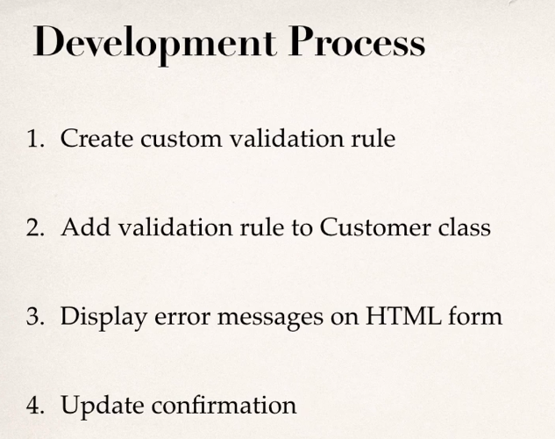

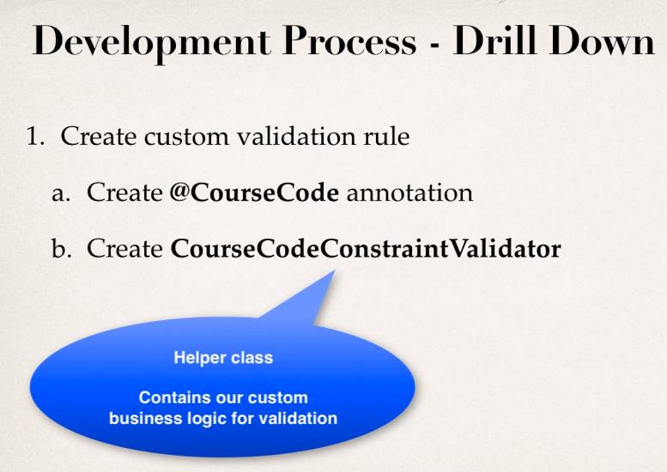

CustomValidation:
Perform custom validation based on your business rules; for example: Course code must start from ‘LUV’. Spring MVC calls our custom validation. Custom validation returns boolean value for pass/fail(true/false). For custom validation , we will use custom Java Annotation (Example: @CourseCode).
Steps:
- Create custom validation rule: First of all, create an @interface. It is an interface only but it is used to define a custom annotation for anything in Java. It has annotations like @Constraint(it consists of a helper class that contains business rules/ validation logic), @Target(It will allow your interface name to be used as annotation to a method or field), @Retention(it will determine how long should we return it. The Retention =Policy class in it will retain this annotation in the java class file), etc. The variables defined in this interface will be used as a parameter in the annotation. Now a new class is formed which will be used as a validator. A method formed for validation will check about the specific constraint and will return data according to the constraints.
- Add validation rule to object class
- Display error messages on HTML form
- Update confirmation page.

HIBERNATE
It is a framework for persisting/saving Java objects in a database. Hibernate handles all of the low-level SQL. It minimizes the amount of JDBC code you have to develop. Hibernate provides the Object-to-Relational Mapping(ORM). There is a mapping available for mapping the class to a given database table. Session is a special hibernate object. When we use session.save(Object) then Hibernate will take that Java object based on the mappings defined earlier. Hibernate will take that info and store it in the appropriate table in the appropriate columns. Using session.save, Hibernate will return the actual ID that’s been assigned to that entry. Session.get is used to return the object.

Entity Class: It is a Java class that is mapped to a database table. It is a simple POJO class with fields and getters and setters. You simply add annotations to it to help with mapping it to a database table.
Two options for mapping:
- XML config file (legacy)
- Java Annotations (modern, preferred)
- Steps
1) Map class to database table
2) Map fields to database columns
Session factory: This class reads the hibernate config file, it creates Session objects. We create an object of this class. This Session factory object is created only once and that’s why it is called a Heavy-weight object. It will be used to create sessions.
Session: This class is a wrapper around a JDBC connection to a database. The session is the main object that is used to save/retrieve objects. It is a short lived object. For a given method, you will use that object and now this object is destroyed and then you will create another session for another method. Session object is retrieved from Session Factory.

In hibernate, we assign the primary key using @Id and @GeneratedValue(strategy=GenerationType.IDENTITY) annotations. There are other methods also like:
GenerationType.AUTO → Pick an appropriate strategy for the particular db.
GenerationType.IDENTITY → Assign primary keys using database identity column.
GenerationType.SEQUENCE → Assign primary keys using a database sequence.
GenerationType.TABLE → Assign primary keys using an underlying database table to ensure uniqueness.
NOTE: You can define your own Custom generation strategy. BUT you have to make sure that your generator will always create unique value. This strategy should work in high-volume, multi-threaded environment. If we make and use server clusters, always generate unique v
Steps:
- Create implementation of org.hibernate.id.IdentifierGenerator
- Override the method: public Serializable generate(...)

CRUD work in hibernate:
To Create:
- Create an object and enter data.
- session.beginTransaction();
- session.save(object).
- session.getTransaction().commit();
To Read:

Retrieving java object with hibernate :
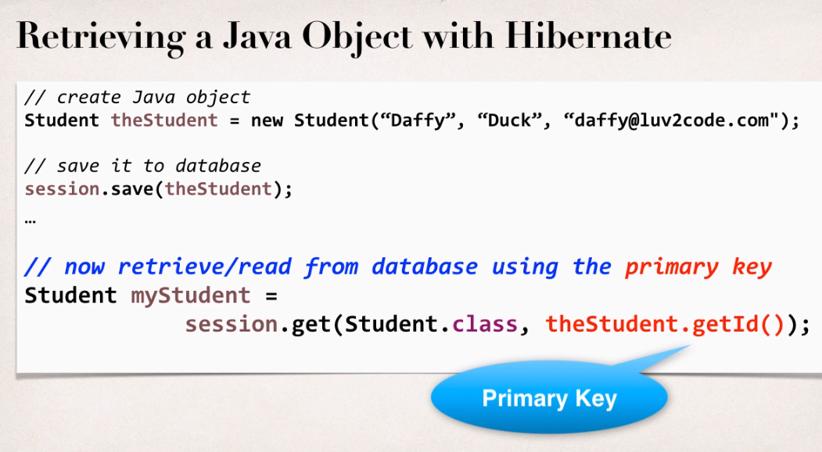
- Using print statement.
- For all data, create a list and then display it using looping.

To Update: can be done in two ways:
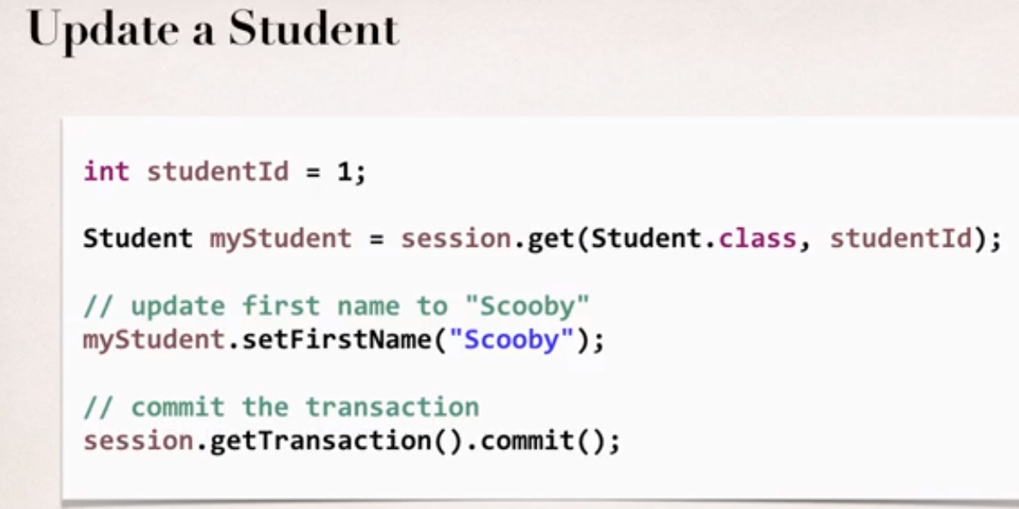
- Using setter method of that variable.
- Using createQuery(“update [tableName] set field = ‘desiredValue’ ”).executeUpdate();
To Delete: same as update
- Using session.delete(object);

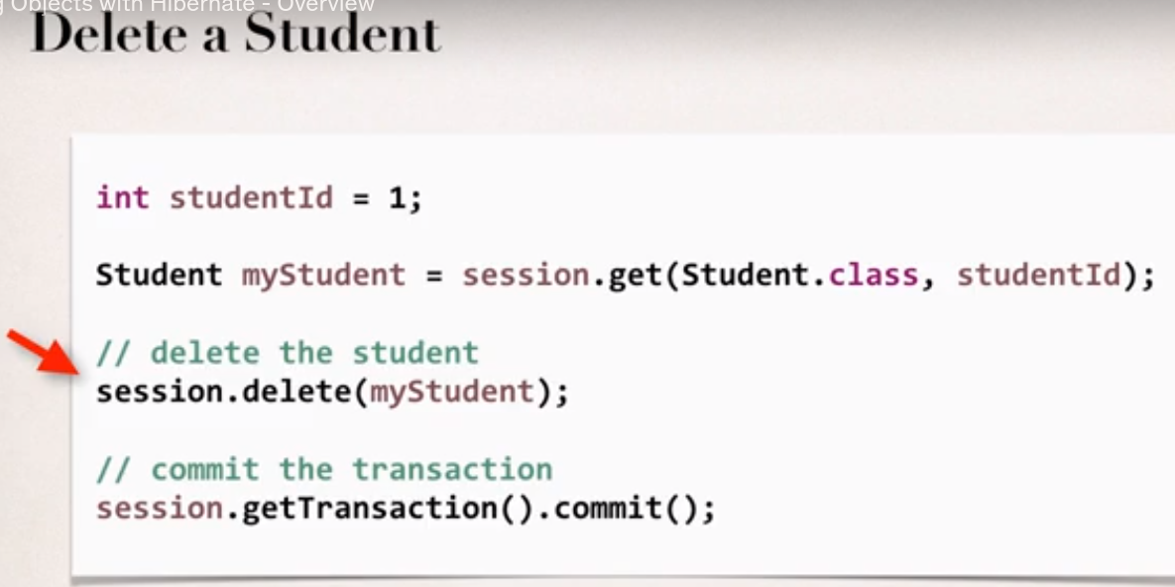
- Using createQuery();
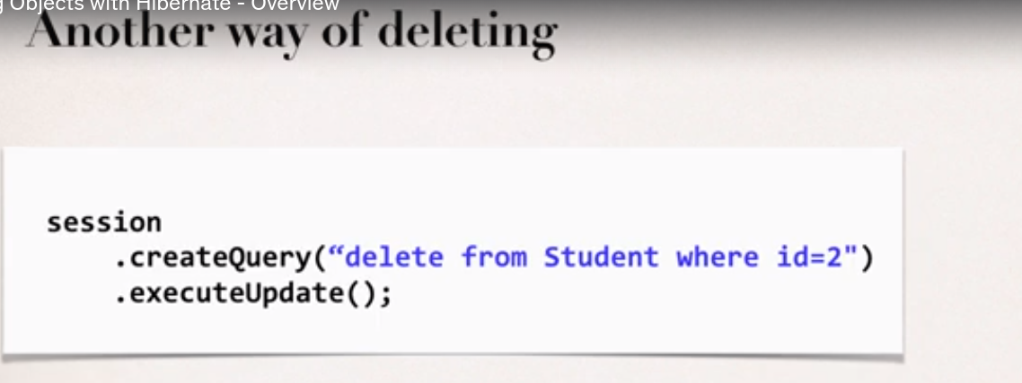

ENTITY LIFECYCLE:
If an object is created using ‘new’ keyword then it is called t o be in a Transient state.
- Detach: If an entity is detached, it is not associated with a Hibernate session.
- Merge: If an instance is detached from session, then merge will reattach to session.
- Persist: Transitions new instances to managed state. Next flush/ commit will save in db.
- Remove: Transitions managed entity to be removed. Next flush/ commit will delete from db.
- Refresh: Reload/ sync object with data from db. Prevents stale data.

Mapping:
One to One mapping in Hibernate:
After creating a database in sql, during class creation to assign a field as foreign field, use @OneToOne,@JoinColumn(fieldName in another class which is joined with it) annotation.
As a developer, we can specify the actual cascade type that we want them to use. Some types are as follows:
- Persist: If entity is persisted/saved, related entity will also be persisted.
- Remove: If entity is removed/ deleted, related entity will also be deleted.
- Refresh: If entity is refreshed, related entity will also be refreshed.
- Detach: If entity is detached(not associated with session), then related entity will also be detached.
- Merge: If entity is merged, then related entity will also be merged..
- All: All of above cascade types.
This is unidirectional mapping. We can do bidirectional mapping also.To use Bidirectional mapping, we don’t have to make changes in the database schema. We just have to update the Java code.
- It is done by @OneToOne(mappedBy=’objectName’). This tells Hibernate to look at the following property in this class and use information from the class mentioned in the @JoinColumn(name=’ColumnName’). It is used to find the associated instructor.
- @mappedBy: Here the field of the other class with which the mapping is to be done is mentioned. This annotation is used on the class field where the data of the other class’s field is to be stored.

One To Many mapping:
- Don’t apply cascading delete in it.
- The relation is mostly bidirectional. One object can have relation with many objects of other class. SO we can use list interface to specify it. In the other class, we can use @JoinColumn annotation to give relations.

Fetch Types; Eager vs Lazy Loading:
When we fetch / retrieve data, Eager will retrieve everything. Lazy will retrieve on request.
- Eager loading will load all dependent entities. In large web applications, it will greatly affect the performance.
- Best practice is to only load data when absolutely needed. Prefer Lazy loading instead of Eager loading.
- Lazy loading will load the main entity first. Then it will load dependent entities on demand(that’s why it is called lazy). It will make the application run on a fast manner.
- In MASTER view, use Lazy loading. In DETAIL view, retrieve the entity and necessary dependent entities.
- When you are defining the mapping relationship, at that time you can specify the fetch type as EAGER or LAZY. (fetch = fetchType.EAGER)
- Default fetch types of different mapping relationships:
  - @OneToOne: Eager
  - @OneToMany: Lazy
  - @ManyToOne: Eager
  - @ManyToMany: Lazy
- When you lazy load, the data is only retrieved on demand. However this requires an open Hibernate session i.e need an connection to database to retrieve data. If Hibernate session is closed and you attempt to retrieve lazy data, Hibernate will throw an exception.
- To retrieve lazy data,
- Session.get and call appropriate getter methods.
- Hibernate query with HQL: This will make the above statements to be executed while the session was open. This have loaded the data in memory using Hibernate Query with HQL. It will load instructor and courses all at once(HQL Join Fetch)
- Both the above methods are good but it will negate the use of Lazy loading. Instead of that, by using a new session, and using HQL , we can load it later.

One to Many Mapping: Unidirectional:
Here the relationship would be such that if u delete the main class then its corresponding class having its primary key should also be deleted. E.g Reviews without courses have no meaning.

NOTE: How does @JoinColum know where to find the join column?
The JoinColumn is actually fairly complex and it goes through a number of advanced steps to find the desired column. The table in which it is found depends upon the context.
- If the join is for a OneToOne or ManyToOne mapping using a foreign key mapping strategy, the foreign key column is in the table of the source entity or embeddable.
- If the join is for a unidirectional OneToMany mapping using a foreign key mapping strategy, the foreign key is in the table of the target entity.
- If the join is for a ManyToMany mapping or for a OneToOne or bidirectional ManyToOne/OneToMany mapping using a join table, the foreign key is in a join table.
- If the join is for an element collection, the foreign key is in a collection table.
ManyToMany Mapping:
Between two classes, many objects of one class can have relationships with many objects of another class. To maintain the relationships between classes like these, we use JoinTable. A join table is a table that provides a mapping between two tables. It has foreign keys for each table to define the mapping relationship.
____________________________________________________________________________
- DATA ACCESS OBJECT(DAO):
- It is responsible for interfacing with the database. It’s just a helper class or a utility class for talking to the database. E.g we can use Hibernate API for accessing the data and then sending it back to whoever called the method; in our case it would be the controller only. For Hibernate, our DAO needs a Hibernate SessionFactory.

- The data source is connected with Session factory and it defines the database connection information. It will tell how to actually connect to the database i.e userID, Password etc.
- These all are dependencies. We can wire them together with Dependency Injection(DI).
- Spring provides an @Transactional annotation. It automagically begin and end a transaction for your Hibernate code. There is no need for you to explicitly do this in your code. This happens behind the scenes. It makes your code compact.
- Spring provides the @Repository annotation for DAOs. @COmponent will do component scanning for you. @Controller will be placed on a special class which will handle all of your Spring MVC work. @Repository is placed on your actual DAO implementation classes. It is a sub-class of @Component class that means your DAO implementation will be available for auto-scanning or component scanning.
- @Repository is applied of DAO implementations. Spring will automatically register the DAO implementation thanks to component scanning. Spring also provides translation of any JDBC related exceptions.

When you send data over to a spring MVC controller, you normally have an HTML form. You send over a request, the controller will process it and send you back a response. The GET Request and POST Request are the most commonly used HTTP methods.
- GET: to send over data with the Get method, you set up your form and the key item here is to mention method = “GET”. So in that case, when form data is submitted, it’s actually appended to the end of the URL as name:value pairs. We can also use @GetMapping annotation.
  - Good for debugging
  - Bookmark or email URL
  - Limitations on Data length.
- By default all methods are allowed if we don’t explicitly mention the method type.
- POST: In this case, the form data is passed in the body of the HTTP request message. We can also use @PostMapping annotation.
  - Can’t bookmark or email URL
  - No limitations on Data length
  - Can also send binary data

Spring provides @Services annotation. It’s a specialized annotation for Services. It is applied to the service implementation.It is between controller and DAO. So spring will actually automatically register the service implementation due to component scanning.
It is a good practice to let the SERVICE define the @Transactional layer and then the DAOs run in that same context.

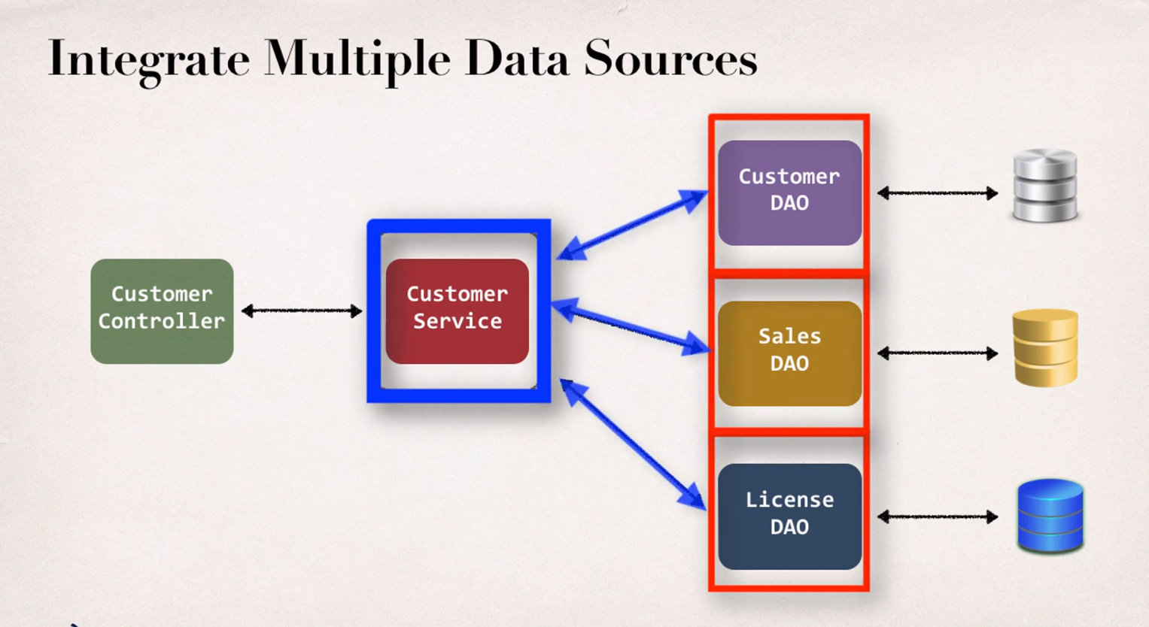

NOTE: Why use Service Layer as additional?
In real world applications, there are many methods which vastly differ from each other. It is important to use service layer to integrate multiple data sources(daos) and perform transaction management between the two. When there are multiple DAOs the Services can be used to manage the transactions between different DAOs.You can use @Transactional at the service layer if you want DAO methods to run in the same transaction.

ASPECT ORIENTED PROGRAMMING

If you want to add a specific method to all the layers of the project or whole system, there are many ways:
- Create a sample code and paste it in every layer of system.
  - Cons:
    - Code Tangling: If we create one method for whole layer then there will be entanglement between two different methods. So this is also not desirable.
    - Code Scattering: If we want to change a method, then we have to update all the classes.

- We can use Inheritance.
  - Cons:
    - Every class would be needed to inherit from a base class.
    - But it is not good to inherit all classes from an base class, just to add a simple method.
    - In addition to that, Java does not support multiple inheritance.
- We can use Delegation:Classes would delegate the call of methods.
  - Cons:
    - We still need to update classes if we want to add/ remove any of the method.
    - We still need to update classes if we want to add new features in the methods.
That’s why Aspect Oriented Programming was introduced. It’s a programming technique based on the concept of an Aspect. Aspect encapsulates the cross-cutting logic/concerns/functionality (basic infrastructure code that all applications will need). Here we have to encapsulate the code of the functionality into a reusable module or reusable class. We can have that code be called when they make appropriate calls to any specific controller. Therefore, an aspect can be reused at multiple locations. The same aspect/class can be applied to anywhere based on configuration.
Pros of AOP:
- Code for aspect is defined in a single class:
  - Much better than being scattered everywhere.
  - Promotes code reuse and easier to change.
- Business code in your application is cleaner.
  - Only applies to business functionality.
  - Reduces code complexity.
- Configurable:
  - Based on configuration, apply Aspects selectively to different parts of app.
  - No need to make changes to main application code.
- Most Common APO useCases :
  - Logging, security, transactions
- Audit logging:
  - Who ,what, when , where
- Exception handling:
  - Log exception and notify DevOps team via SMS/ email
- API management:
  - How many times has a method been called user.
  - Analytics: what are peak times? What is average load? Who is top user?
Disadvantages;
- Too many aspects will make app flow to be hard to follow.
- Minor performance cost for aspect execution (run-time weaving).

> ASPECT : module of code for a cross-cutting concern(logging, security, etc..)
> ADVICE : what action is taken and when it should be applied
> JOIN POINT : When to apply code during program execution.
> POINTCUT : A predicate expression for where advice should be applied. It will tell the spring to apply the code if the conditions mentioned are matched.

> Before advice : run before the method.
> After finally advice : run after the method (finally).
> After returning advice : run after the method (success execution).
> After throwing advice : run after method (if exception thrown).
> Around advice : ru before and after method.

>Weaving: Connecting aspects to target objects to create an advised object. Different types of weaving: Compile-time weaving, load-time weaving, run-time weaving. Regarding performance: run-time weaving is the slowest.

AOP is provided by Spring and Aspect J.
Spring AOP Support:
- Spring provides AOP support out of a box and it actually uses AOP in the background.
- It uses AOP for security, transactions, caching, etc. All these are built into the spring framework automatically. We will write our own AOP stuff on top of that functionality.
- Spring makes use of run-time weaving of aspects. For example, Spring makes use of the proxy pattern to advise an object. The main application will talk to a proxy, all the aspects are processed and then it makes it to the actual target object.
- Spring AOP is a light implementation of AOP. It solves common problems in enterprise applications.
- ADVANTAGES:
  - Simpler to use than AspectJ
  - Use Proxy Pattern
  - Can migrate to AspectJ when using @ASpect annotation.

- DISADVANTAGES:
  - Only supports method- level join points.
  - Can only apply aspects to beans created by Spring app context.
  - Minor performance cost for aspect execution (run-time weaving)
AspectJ AOP:
- It provides complete support for AOP.
- If you have complex requirements then move to AspectJ.
- It has rich support for:
  - Join points : method-level, constructor, field.
  - Code weaving : compile-time, post compile-time and load-time.
- ADVANTAGES:
  - Support all join points.
  - Works with any POJO, not just beans from app context.
  - Faster performance compared to Spring AOP.
  - Complete full-stack AOP support.

- DISADVANTAGES:
  - Compile-time weaving requires extra compilation step.
  - AspectJ pointcut syntax can become very complex.
Steps:
- Create Target Object.
- Create Spring Java Config Class. @EnableAspectJAutoProxy: this annotation on the Spring Java Config class is used to apply Spring AOP proxy Support.
- Create Main app.
- Create an Aspect with @Before advice: First of all @Aspect annotation is used on the class to refer it as an Aspect. In this class this @Before annotation is used to say the compiler that before this method is called, run this code allocated to @Before. In before there is a target object method called which is known as Pointcut expression which is as follows: @Before(“execution(public void methodName())”)
→Keep the code small
→Keep the code fast
→Do not perform any expensive/slow operations
→Get in and out as Quickly as possible

Pointcut Expression Language:
- Spring AOP uses AspectJ’s pointcut expression language.
- Execution pointcuts:
  - Applies to execution of methods
  - The pattern in execution is optional if it has ‘?’.
  - The pattern in execution will apply compulsory if it has ‘*’. ‘*’ can also be used for return type. It means the method will return any type of output.
  - The modifier and declaring type are optional.
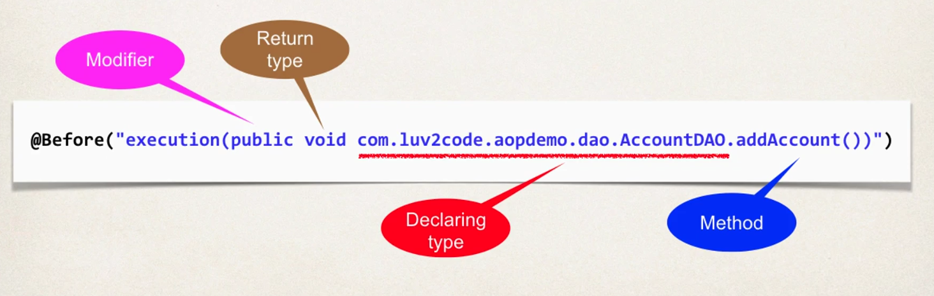
For parameter pattern:
- () - matches a method with no arguments
- (*) - matches a method with 0 or more arguments of any type.
- (..) - matches a method with 0 or more arguments of any type.
To reuse a pointcut expression i.e apply it to multiple advices:
- Create a pointcut declaration once using @Pointcut on the method to be declared. The we can call that method by using @before(‘methodname’) or any other annotations
- Apply pointcut declaration to advice(s)
Benefits:
- Easily reuse pointcut expressions
- Update pointcut in one location
- Can also share and combine pointcut expressions
To apply multiple pointcut expressions to single advice OR
Execute an advice only if certain conditions are met: For example on every method except get and set method.
- Combine pointcut expressions using logic operators:
  - AND(&&)
  - OR(| |)
  - NOT(!)
- It works like an if statement:
  - It executes only if the statement is true.
Steps:
- Create a pointcut declarations
- Combine pointcut declarations
- Apply pointcut declaration to advice.
How to control the order of advices being applied?
To control order:
- Refractor: place advices in separate Aspects
- Control order on aspects using the @Order annotation
- Guarantees order when Aspects are applied.
Steps:
- Refractor: place advices in separate aspects
- Add @order(i) (where i is the rank of execution of methods) annotation to aspects
If two aspects have exact same order annotation then between them, the order will be undefined but the orders between which they are present, that order will continue.

When we are in an aspect( i.e for logging) how can we access method parameters?
Steps:
- Access and display Method signature by adding a new argument called JoinPoint which is used to give us metadata about the method under execution. Then we have to create a MethodSignature object in aspect and call the JoinPoint attribute in it.
- Access and display Method Arguments: Here we can make use of the JoinPoint Parameter for advice. It can give arguments OR an array of arguments using loop.
It will display the actual method signature of the method being associated with the aspect.

@AfterReturning: This advice will run after the method call(success execution)
- It is similar to @Before annotation.
- Using ‘returning’ attribute in AfterReturning annotation, we can access the returning value under condition the same parameter mentioned in the attribute will be used in the method.

